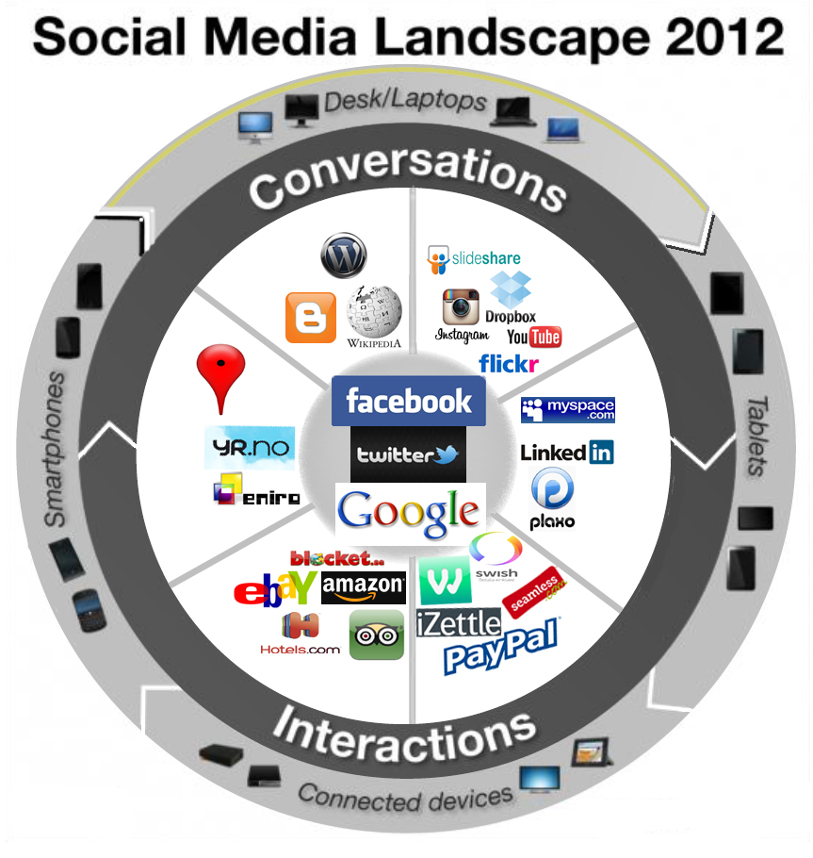
TRAVEL SOCIAL MEDIA LANDSCAPE SWEDEN 2013- source Hellman&Cavazza

