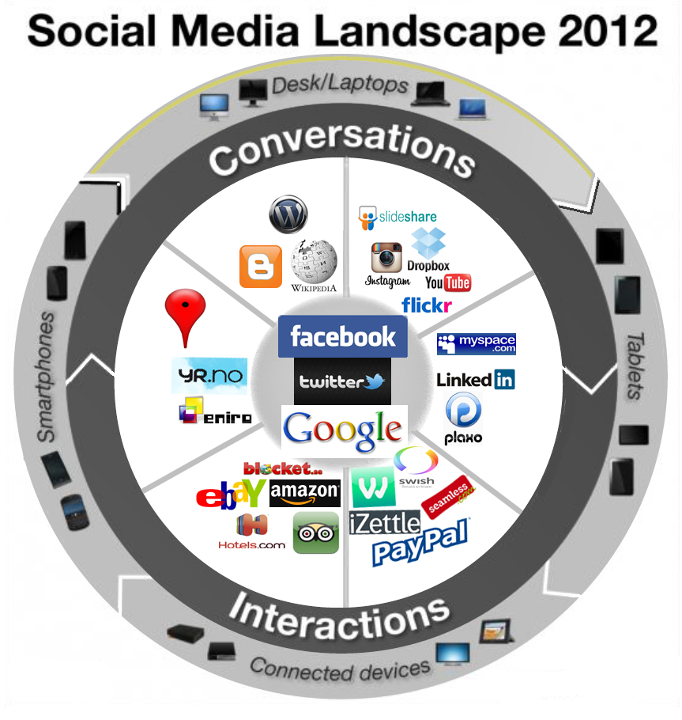
P HELLMAN- TRAVEL SOCIAL MEDIA LANDSCAPE SWEDEN 2013

